**Name: Hoang Duc Khanh Student ID: 20155889**

**Lab: Industrial Networks and Power Electronics Laboratory (INPEL)**

Class: MECHANICS AND CONTROL OF ROBOT MANIPULATORS

Instructor: Prof. Kang, Hee-Jun

Home Work 7

The current configuration of the two link manipulator is given below as you can see the class material for chap.6.

Real parameter m1= 5kg; m2= 3kg; l1=l2= 0.5m

θ1(0) = 300; θ1(tf) = 1500 tf= 0.5 sec



θ2(0) = 1200; θ2(tf) = 300



1. Do trajectory planning with a cubic polynomial for the two joints of the manuipulator.

Using the dynamic equation in text.

1. Perform PD control simulation (Simulink is also accepted)
2. Perform PD + gravity control simulation.
3. Perform computed torque control simulation
4. Compare errors of 3 cases above

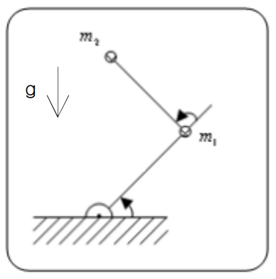

Solutions

1. Set up cubic trajectory:

θ1(0) = 300= π/6 θ1(tf) = 1500= 5π/6

θ2(0) = 1200= 2π/3 θ2(tf) = 300= π/6

By the innitial condition:

$$θ\left(0\right)=a_{0}=\left[\begin{matrix}\frac{π}{6} \\ \frac{2π}{3}\end{matrix}\right]$$

$$\dot{θ}\left(0\right){=a}_{1}=\left[\begin{matrix}0 \\ 0\end{matrix}\right]$$

By the final condition:

$$θ\left(1\right)=\left[\begin{matrix}\frac{5π}{6} \\ \frac{π}{6}\end{matrix}\right]$$

$$\dot{θ}\left(1\right)=\left[\begin{matrix}0 \\ 0\end{matrix}\right]$$

Then:

$$a_{0}=θ\left(0\right)=\left[\begin{matrix}\frac{π}{6} \\ \frac{2π}{3}\end{matrix}\right]$$

$$a_{1}=\dot{θ}\left(0\right)=\left[\begin{matrix}0 \\ 0\end{matrix}\right]$$

$$a_{2}=\frac{3}{{t_{f}}^{2}}\left(θ_{f}-θ_{0}\right)-\frac{2}{t_{f}}{\dot{θ}}_{0}-\frac{1}{t_{f}}{\dot{θ}}_{f}=\frac{3}{{0.5}^{2}}*\left[\begin{matrix}\frac{2π}{3} \\ -\frac{π}{2}\end{matrix}\right]=\left[\begin{matrix}8π \\ -6π\end{matrix}\right]$$

$$a_{3}=-\frac{2}{{t_{f}}^{3}}\left(θ_{f}-θ_{0}\right)+\frac{1}{{t_{f}}^{2}}\left({\dot{θ}}_{f}+{\dot{θ}}_{0}\right)=-\frac{2}{{0.5}^{2}}\left[\begin{matrix}\frac{2π}{3} \\ -\frac{π}{2}\end{matrix}\right]=\left[\begin{matrix}-\frac{16π}{3} \\ 4π\end{matrix}\right]$$

We got the result:

$$\left\{\begin{aligned}θ\left(t\right)=\left[\begin{matrix}\frac{π}{6}+8πt^{2}-\frac{16π}{3}t^{3} \\ \frac{2π}{3}-6πt^{2}+4πt^{3}\end{matrix}\right] \\ \dot{θ}\left(t\right)=\left[\begin{matrix}16πt-16πt^{2} \\ -12πt+12πt^{2}\end{matrix}\right] \\ \ddot{θ }\left(t\right)=\left[\begin{matrix}16π-32πt \\ -12π+24πt\end{matrix}\right]\end{aligned}\right.$$

Find Torque Trajectory for the obtained trajectory:

$$τ=M\left(Θ\right)\ddot{Θ}+V\left(Θ,\dot{Θ}\right)+G(Θ)$$

$τ_{1}=$ $m_{2}l_{2}^{2}\left({\ddot{θ}}_{1}+{\ddot{θ}}_{2}\right)+m_{2}l_{1}^{ }l_{2}^{ }c_{2}^{ }\left({2\ddot{θ}}_{1}+{\ddot{θ}}_{2}\right)+\left(m_{1}{+m}_{2}\right)l_{1}^{2 }{\ddot{θ}}_{1}-m_{2}l_{1}^{ }l_{2}^{ }s_{2}^{ }{\dot{θ}}_{2}^{2}$

$$-2m_{2}l_{1}^{ }l_{2}^{ }s_{2}^{ }{\dot{θ}}_{1}^{ }{\dot{θ}}_{2}^{ }+m_{2}l_{2}^{ }gc_{12}^{ }+\left(m_{1}{+m}_{2}\right)l_{1}^{ }gc_{1}^{ }$$

$τ_{2}=$ $m_{2}l_{1}^{ }l_{2}^{ }c_{2}^{ }{\ddot{θ}}_{1}+m_{2}l_{1}^{ }l_{2}^{ }s_{2}^{ }{\dot{θ}}_{1}^{2}+m_{2}l_{2}^{ }gc_{12}^{ }+m_{2}l_{2}^{2}\left({\ddot{θ}}_{1}+{\ddot{θ}}_{2}\right)$

Use Matlab to calculate, we got this result as follow:

The angle trajectory and error:

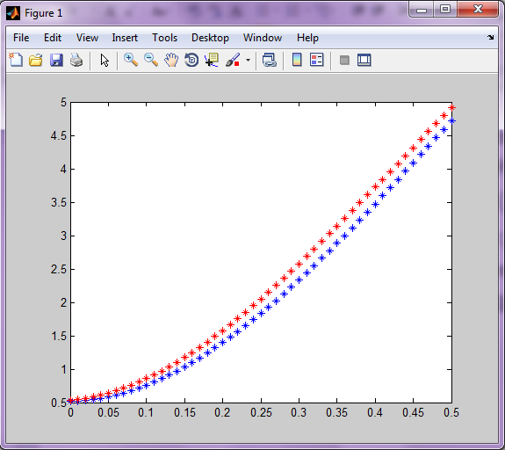

Real angle

Desired angle

Figure 1. Angle trajectory of joint 1

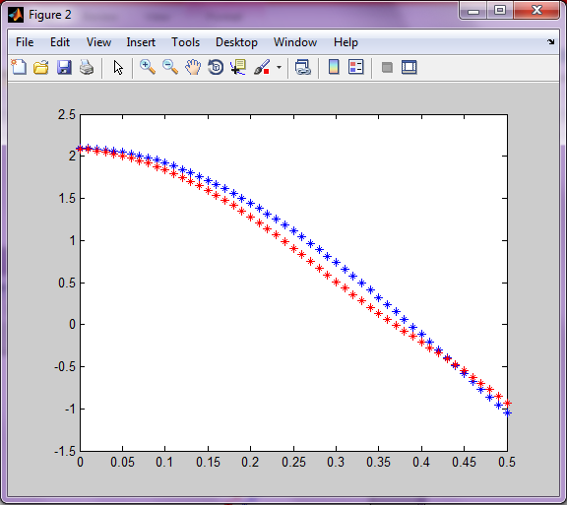

Real angle

Desired angle

Figure 2. Angle trajectory of joint 2

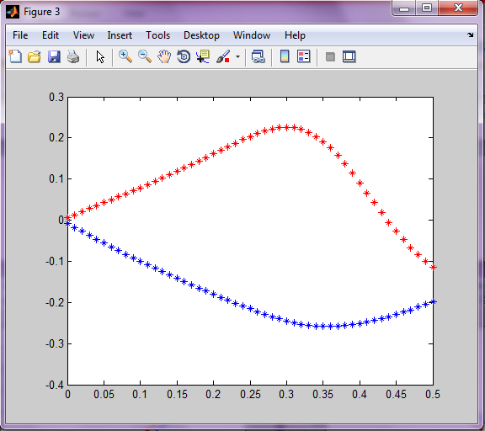

Link 2

Link 1

Figure 3. Error of the joint angle

1. Perform PD control:

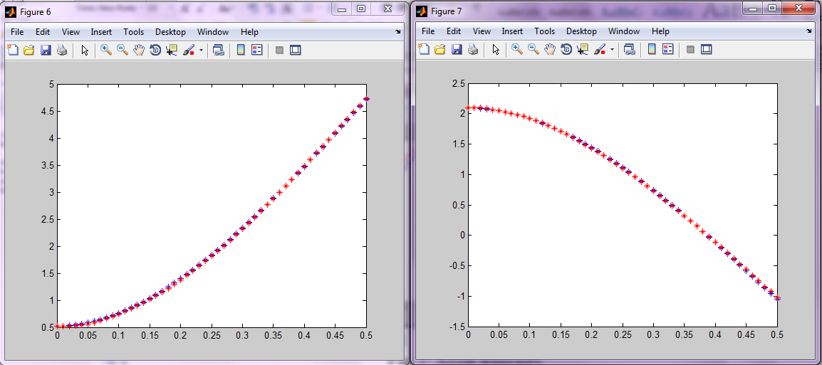

(a) (b)

Figure 4. Angle trajectory of PD control: a) angle of joint 1, b) angle of joint 2

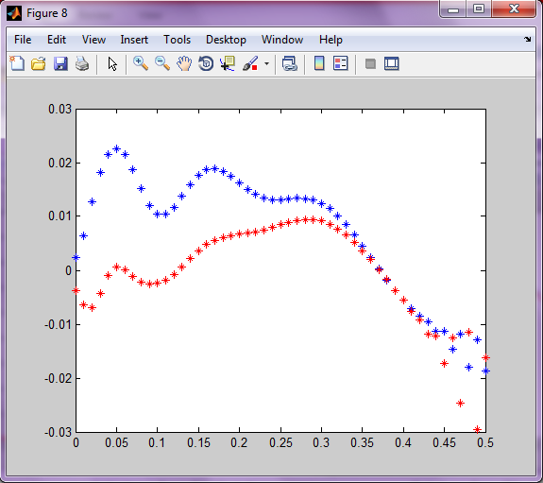

Figure 5. Error of the joint angles

1. Perform of PD + gravity control

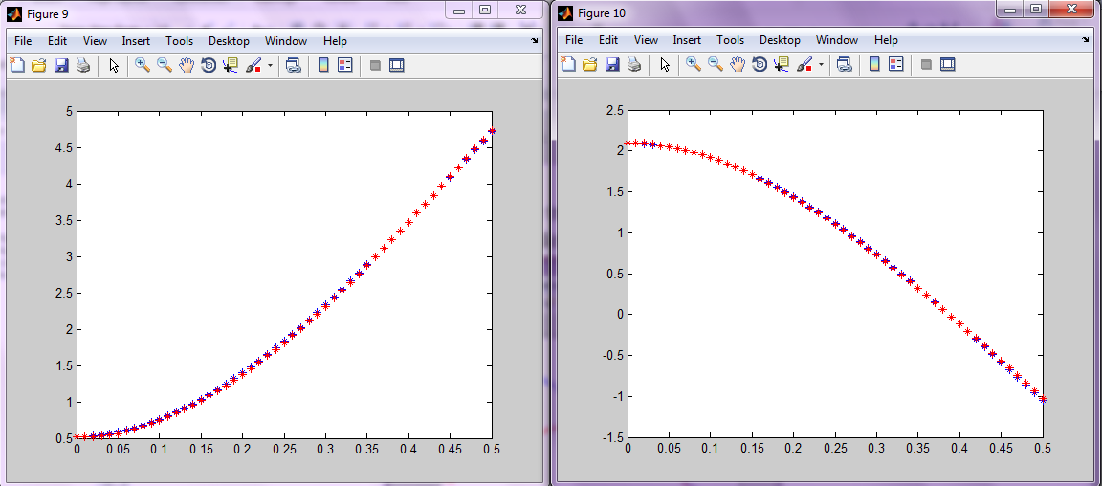

(a) (b)

Figure 6. Angle trajectory of PD + gravity control: a) angle of joint 1, b) angle of joint 2

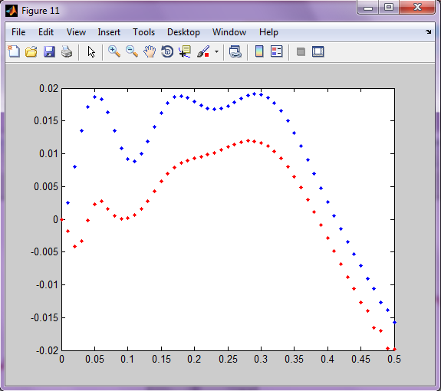

Figure 7. Error of the joint angles

1. Perform compute torque control

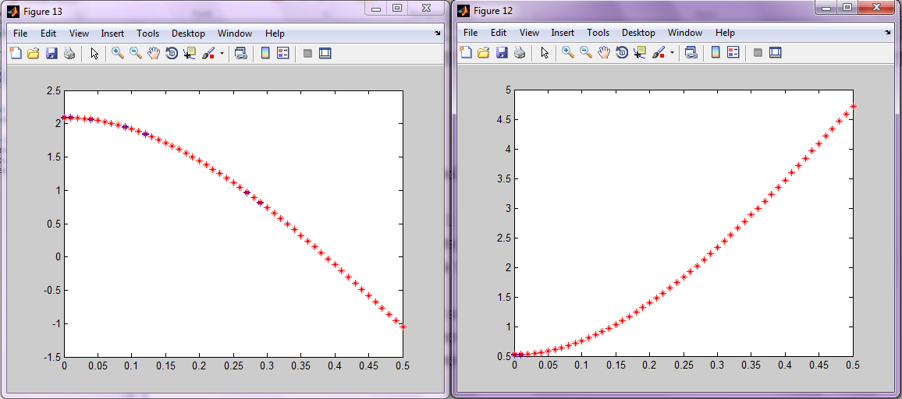

(a) (b)

Figure 8. Angle trajectory of compute torque control: a) angle of joint 1, b) angle of joint 2

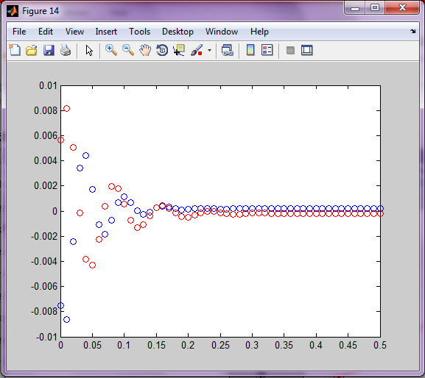

Figure 9. Error of the joint angles

1. Comparing from the result of the controllers:

We compare the result by draw the angles’s error of each jont on the same figure:

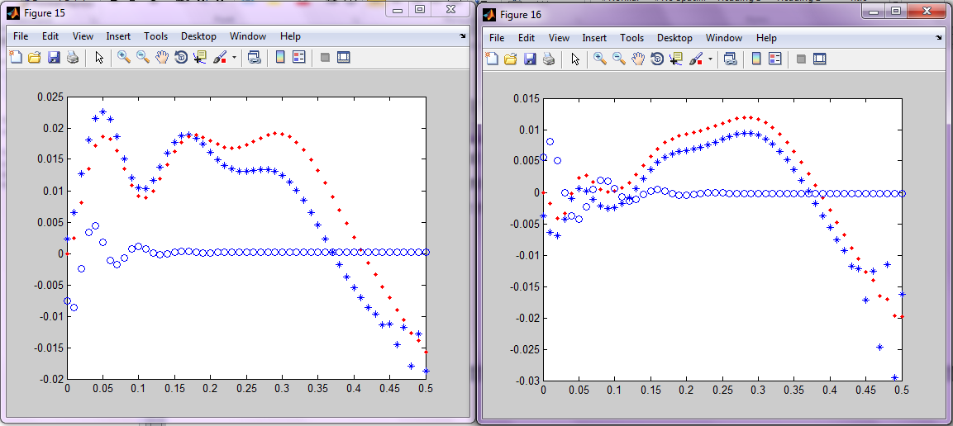

1. (b)

Figure 10. Error of the joint angles :a) joint 1, b) joint 2

In both cases. The blue O line is the error of torque compute control method

The blue * line is the error of PD+gravity control method

The red . line is the error of PD method control method

We can say that the PD control method is not as good as PD+ gravity method

The compute torque control method is better than PD+ gravity method

(Definitely the result show that in the case of no controller, it is the worst case)